Solution Manager FRD Assessment (determines SM’s review loop)
Author(s): Achim Voermanek Check one: Simple [ ] Complex [ x ]
Document Version: see below [ ] Engineering FT review [ x ]
Target Release(s): 13s3 [ ] GSO review [ x ]
Solution: Quadrem Integration [ ] Cross-solution team review [ x ]
Feature ID: 607 [ ] Architect review [ x ]
[ ] Single customer review [ ]
FRD Template: 005 Multiple customer review [ x ]
Solution Consultant review [ ]
Support review [ ]
[ ] Solution Owner review [ x ]

13s3-607 Order Management – Order Status Request

Version | Date | Author | Change Summary
0.01 | 3/12/2012 | Achim Voermanek | Initial Creation
0.50 | 4/13/2012 | Achim Voermanek | Use cases
0.60 | 5/2/2012 | Achim Voermanek | UI ideas
0.90 | 5/31/2012 | Achim Voermanek | AN UI Update
1.00 | 6/02/2012 | Achim Voermanek | Stat data added
2.00 | 6/21/2012 | Vanessa Castro | Business Requirements section updated
2.10 | 7/12/2012 | Achim Voermanek | Updated UI ideas
2.20 | 7/24/2012 | Achim Voermanek | More Detailed UI flows
2.30 | 9/24/2012 | Achim Voermanek | Review/Details of UIs
2.40 | 4/9/2013 | Achim Voermanek | Review/Details of UIs
2.50 | 5/9/2013 | Achim Voermanek | OC as standard answer, notification settings for sellers added

Index / TOC
1 1-Pager Summary 3
1.1 Short Description 3
1.2 High Level Requirements 4
1.2.1 General 4
1.2.2 Buyside 4
1.2.3 Sellside 4
1.3 Who are the business users 4
1.4 Who is the economic buyer 4
1.5 Dependencies 4
1.6 Business Impact 4
1.7 Customer Validation Strategy 4
1.8 Other Considerations 4
2 Detailed Functional Requirements 5
2.1 Business Requirements 5
2.2 Definitions 9
2.3 Data Import/Export & ERP Integration 9
2.4 Reporting Impact 9
2.5 Product Packaging and Limited Entitlements 9
2.6 Performance and Capacity Guidelines 9
2.7 Special Readiness Issues 9
3 Use Cases 10
3.1 Functional Use Cases 10
4 Feature Requirements 13
4.1 < Feature name XXX (Must, Should, Nice to have)> 13
4.1.1 < Detailed Feature > 13
4.2 < Feature name XXX (Must, Should, Nice to have)> 13
4.3 Reports External / Internal 13
4.3.1 < New report XXX or impacted existing report XXX > 13
4.3.1.1 < Report-specific characteristics > 13
4.3.1.2 < Report “Mock-up” > 13
5 User Impact and Change Management 14
5.1 Part 1: Impact Assessment 14
5.2 Part 2: Special Communication, Training Requirements 14
5.2.1 Change management communication tools 14
5.2.1.1 Knowledge Transfer 14
5.2.1.2 Email communication 14
5.2.1.3 UI embedded 15
5.2.1.4 Help 15
6 Appendix 16
6.1 Sample Screenshots (e.g. existing Features) 16

1-Pager Summary

Short Description

The Quadrem Network has the capabilities for buyers and sellers to communicate with messages about a particular order. The request from a buyer is called Order Status Request; the answer from the seller is communicated via an Order Status Result message. These messages are created on the buyer side in an ERP system that is connected to the Quadrem Network, on the sell side a UI is offered via SupplyCentre which allows suppliers to respond to the requests from buyers. Also an integrated sell side system can be used to respond to the request.

On the QN there are some common use cases for this
- PO-OSReq-OR: In this case the buyer sent the order but the supplier didn’t respond so he/she sent an OSReq requesting information about the Order. After that the supplier sends the OrderResponse (i.e. Anglo Platinum).
- PO-OR-OSReq-OSRes: Here the supplier responded to the Order but didn’t send the items in the date agreed so the buyer sends an OSReq requesting information about the Order. After that the supplier sent the OSRes proposing a new delivery date (i.e. BHPB).
- PO-OR-GRN-INV-RA-OSReq: In this scenario the buyer requested 3 different items in the order. The supplier sent only 2 of them. Even the Invoice is created for those 2 items. After that the buyer sent an OSReq asking for the third item (i.e. Newmont)

As we can see in the examples above, the OSRequest can be received at any moment in the PO orchestration flow (from right after the PO to after the ASN). There is no document choreography or dependency setup for it. The only pre-condition is an existing order.

Most common users of these docs on QN are: Anglo, BHP, Newmont and Samarco.
This is a summary of hosted OSReq/OsRes received/sent on QN during 2011 (they were sent from Buyers ERPs to the QN and responded by the sellers in the application):

Region/Buyer | OSReq # | OSRes #
Africa | 109303 | 37389
Anglo | 25597 | 6455
AngloGold | 83706 | 30934
Australia | 143004 | 46641
Anglo | 27714 | 14147
BHP | 55087 | 9030
Newmont | 60201 | 23461
Thiess | 2 | 3
North America | 5373 | 2917
Newmont | 5367 | 2915
Penoles | 6 | 2
South America East | 1596 | 229
Samarco | 1596 | 226
Vale |  | 3
Grand Total | 259276 | 87176

The latest numbers including data from 2012 state:
423,000 OSReq and
123,000 OS Responses
In general the relationship between OSReq and OSRes is somewhere between 1/3 and ¼. The majority of the answers to OSReq are with OCs.

High Level Requirements

General
- Create cXML messages “Order Status Request”
  - Foundation for that should be the corresponding xCBL message and the 869 EDI message.

Buyside
- Allow AN to consume Order Status Requests via cXML from ERP systems or QN.
- Allow buyers to see Order Status Results from sellers in buyer.ariba.com screens (preferably the Order Status Screen within their outbox).
- Allow AN to route Order Confirmation back to Buyer ERPs and to QN.

Sellside
- Allow AN to forward Order Status Requests via cXML to seller ERP systems
- Allow sellers to see and respond to order status requests from buyers via supplier.ariba.com screens (preferably the Order Status Screen within their Inbox)
- Allow for sellers to use the OC function on AN to respond
- Allow AN to consume Order Confirmation (also EDI message 855) from seller’s ERP systems

Who are the business users

Who is the economic buyer

Dependencies

Business Impact
Revenue
Reduction in Cost
Customer Satisfaction Impact
User Impact/User Change Management
Data Import/Export & ERP Integration
Reporting
Product Packaging
Performance and Capacity Guidelines
Competition
Other | < Add any other info that capture the business impact of the feature >

Customer Validation Strategy

Other Considerations

Detailed Functional Requirements

Business Requirements

- Currently: (on Quadrem Network)
The workflow between the Order Status Request (OSReq) and the Order Status Response or Result (OSRes) is the following:

- The buyer generates an OSReq requesting the status of a specific order or asking for information related to some items from the Order.
i.e.: The Purchase Order (PO) or Change Order (CO) could contain 10 items, but the buyer could request the info only for three items.
The document is sent from the Buyer ERP and reaches Quadrem Network.
If it is a hosted document (the supplier is registered on Quadrem applications) the OSReq will appear in the Supplier Worbench in SupplyCentre with Status “New”.
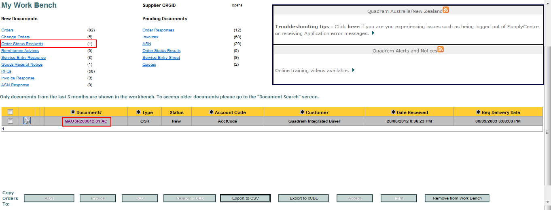
Notes:
- The tpadmin user of the supplier OrgID can configure one or more emails in order to receive a notification when a new document arrives. This could be applied to Order Status Requests too.
- Suppliers are able to export the OSReq xCBL from the workbench, search page and from inside the document.

Integrated OSReq’s go directly to the Supplier ERP (after reaching Quadrem Network).

- After clicking on the Document number QN displays the document information divided in 3 sections: General Information (info about the order and line items), Party Details (Buyer and Seller information) and Notes (General notes at header level sent by the buyer):
All the information appears as read-only.

Note: As we mentioned before, the OSRequest does not necessarily have the same structure than the order. We show in the UI what is sent by the buyer in the xCBL.

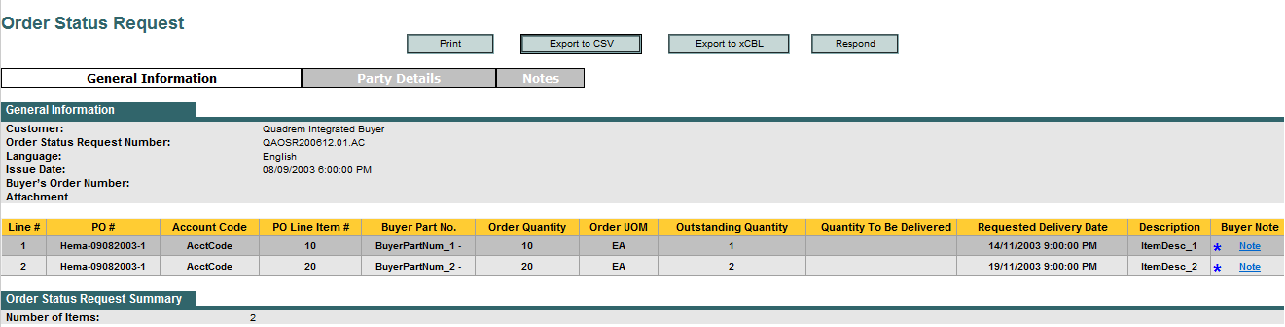
General Information tab

The information sent by line item could be: Order Quantity, Outstanding Quantity, Requested Delivery Date, Description and a buyer note.

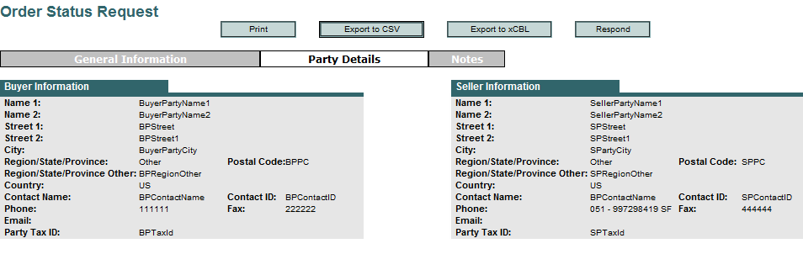
Party Details tab

Notes tab (related to the entire document – header level)
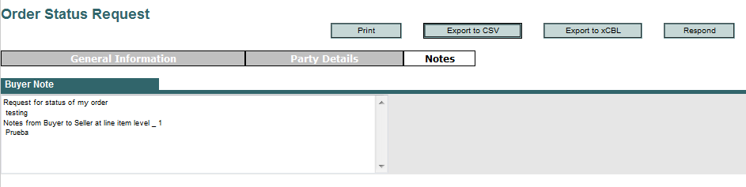

- The supplier clicks on the Respond button in order to create the Order Status Result (OSRes).

Note:
- The OSRes has the same structure than the OSReq. (i.e. if the OSReq has 2 items, the OSRes will show those 2 items too)

General Information tab
In this page the supplier is able to modify the following values: Quantity to be delivered, New Delivery Date, Item Description and the Order Status. Statuses are: Despatched, Not Accepted and Pending.
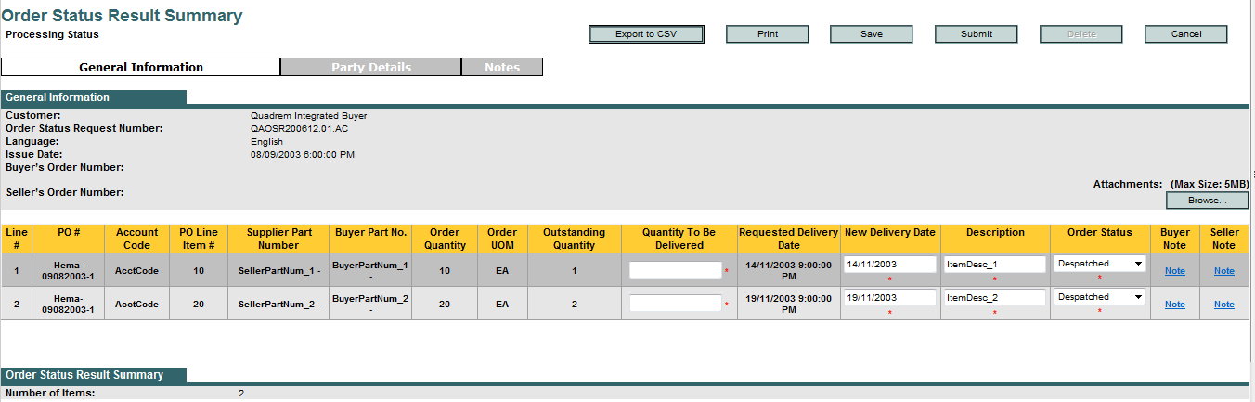
Suppliers can also add an attachment at header level and a note in every line.
Important: The information sent in this document (quantities, dates, statuses) does not affect the rest of the documents in the buyer-seller transaction. It is only informative.

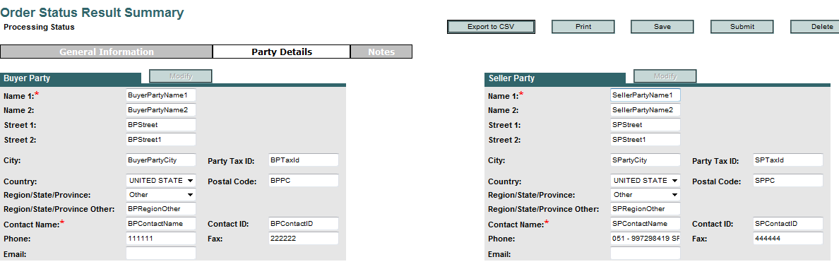
Party Details tab
Buyer/Seller Party information is editable. The supplier can modify the Contact information.

Notes tab
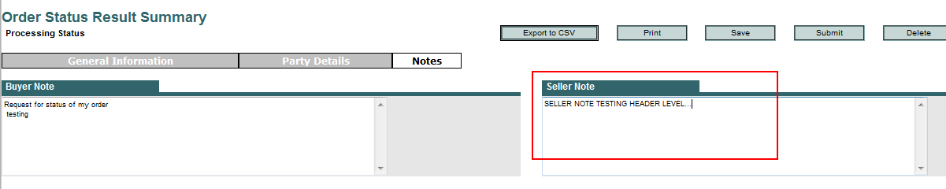
Suppliers can send a note to the buyer at header level.

- After entering all the required information the supplier submit the OSRes and the Xcbl is generated and sent to the Buyer ERP.

Additional Information:

Suppliers can search the order in the “Document History Report” option in order to see all the documents related to it. Though this treeview they can access to all the received and sent documents.
“Sent” documents are read-only.
In that way, if the user has generated more than one OSRes, he/she will be able to review them from this option.
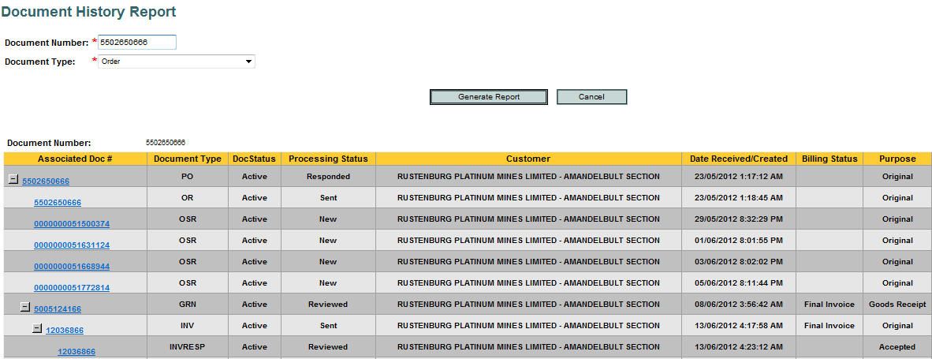

Definitions
- Term ABC – Details ….

Data Import/Export & ERP Integration
< Core baseline is you MUST support backward compatibility which should be specifically stated in your requirements. Define the impact on data import / export and ERP integration. Discuss impact on current integration and proposed new touch points. Don’t forget about client tool / web services plus any special considerations needed to support our current end-to-end “out of the box” support of SAP, Oracle, and PeopleSoft.>
<Details>

Reporting Impact
< Does this change have reporting implications, either (1) impacts one or more existing prebuilt Prepackaged reports; or (2) creates a need for new reports? If so, provide a description of the business purpose of the report(s). While gathering reporting requirements, obtain the following information:
- What overall reporting changes are being requested?
- What is the business purpose for the requested changes?
- What do they hope to accomplish with these changes?
Be sure to provide report-specific information in the Use Case section of this FRD.>

Product Packaging and Limited Entitlements
< Define any packaging ramifications and pay particular attention to both related solutions (P2P vs. P2O; Quick Source vs. Sourcing Pro) and by role entitlements. >

Performance and Capacity Guidelines
< Define requirements that address expected load times, user response times, and other key performance attributes. Also define capacity aspects of your feature. For example, how many records do you expect? What’s the upper end? What about typical usage? >

Special Readiness Issues
< Are there any atypical readiness issues? For example does GSO or support need to hire or build unique skills, such as hire to support a new language? >

Use Cases

Functional Use Cases

ID | Detailed Feature | Priority |  | Area | Estimate |  | Release
10 | Allow AN to consume Order Status Requests via cXML from ERP systems or QN  Example of current OSReq Quadrem xCBL:  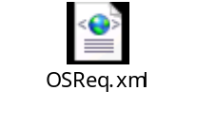 | Must |  | AN
10.10 | One Order Status Request can refer to one PO only. A valid error message should be shown if an OSReq contains references to more than one PO (dispatcher should call out DTD error). | Must |  | AN
20 | Allow buyers to see Order Status Request in buyer.ariba.com screens (preferably the Order History Screen within their outbox) | Must |  | AN
30 | Allow AN to route Order Confirmation back to Buyer ERPs and to QN | Must |  | Buyside Adapter
40 | Seller facing messaging
40.10 | Allow for translation of Order Status Request into 869 EDI message and sending to seller via AN EDI interface | Must |  | EDI Integration
40.20 | Allow sellers to get a notification from AN, once an Order Status Request comes in from a buyer (details see 80) | Must |  | AN
45 | Allow sellers to see historic order status requests from buyers via supplier.ariba.com screens (preferably the Order History Screen within their Inbox) | Must |  | AN
45.10 | The Order Status Requests and their respective OC responses should be shown in a table | Must |  | AN
45.20 | If an OC is created not only in relation to a PO, but also in relation to OSReqs a click on the related documents for this OC number should show not only the related PO, but the related OSReqs as well. | Must |  | AN
45.30 | If the answer to a PO with OSReqs is one or many OCs, a click on the OSReq number should lead the user to the respective OC | Must |  | AN
50 | Allow sellers to respond to active order status requests from buyers via supplier.ariba.com screens (via a selection screen where existing OC options are offered) | Must |  | AN
50.05 | The options presented for the OC have to be governed by the new rule introduced in the 12s3-603 LIA development | Must |  | AN
50.06 | Once an Order Status Request is answered, it will be considered no longer active and will be considered historic.  A OSReq is answered:  - If it only has header level notes  One OC is created as a result of selecting the OSReq  - If it only has header level notes and at least one line item note  - One OC is created as a result of selecting the OSReq, that includes the line item(s) in question  - If it has at least one line item note  - One OC is created as a result of selecting the OSReq, that includes the line item(s) in question | Must |  | AN
50.10 | Allow sellers to edit the following values in the Order Confirmation: Quantity to be delivered, New delivery date, Item Status (on QN it could be “Despatched”, “Pending”, “Not Accepted”)  AN status for "Pending" = "Backordered"  AN status for "Not accepted" = Rejected  AN status for "Despatched" = No Status / Accepted with Comment field for delivery details  Quantity to be delivered and the new delivery date should be prepopulated with PO info (Ordered quantity and Requested Delivery Date)  If an OC is used by a seller for information purposes only then the seller should leave the item status as "unconfirmed". The seller can still specify line item specific data via the OC Line Item Detail screen (Delivery Date, Comments)  If an OC is used by a seller for confirmation purposes then the seller should specify the item status with one of the already existing three options. The seller will then specify line item specific data via the OC Line Item screen (Delivery Date, Comments) | Must |  | AN
50.20 | Allow sellers to enter comments at header and line item level in the Order Confirmation (even when leaving line item information unconfirmed) | Must |  | AN
50.30 | Allow sellers to add an attachment at header level in the Order Status Result. | Must |  | AN
50.40 | A response to all the items sent by the buyer in the Order Status Request (not necessarily all PO line items) must set as mandatory by the buyer. A rule for the buyside is needed to configure this option | Must |  | AN
50.50 | The rule in 50.40 should be enforced only at the seller side via a warning in the seller UI (tooltip/popup) if the seller directly responds to the Order Status Request with an OC.  If the seller responds to the original PO (outside of the OSReq) the rule in 50.40 should not be enforced. | Must |  | AN
60 | Access to “OSReq answer screen” should be given via | Must |  | AN
60.10 | Link in Notification email (direct action) see 80.20 | Must |  | AN
60.20 | Link in banner on PO detail screen | Must |  | AN
60.30 | Link in extra column in already existing PO listing display showing the “active” OSReqs  This list of POs with Active OSReqs should be accessible via | Must |  | AN
60.31 | - The dashboard screen by selecting the number indicating the open Order Status Requests (left hand side, and main body for PO documents) | Must |  | AN
60.32 | - The Inbox screen banner/alert that indicates open OSRequests | Must |  | AN
70 | Seller originating messaging | Must |  | AN
70.10 | Allow AN to consume Order Confirmations as EDI message 855 from seller’s ERP systems | Must |  | EDI team
80 | Allow sellers to configure the email to which notifications about Order Status Requests are received | Must |  | AN
80.10 | Ariba Network/Account Settings/Notifications/Network screen:  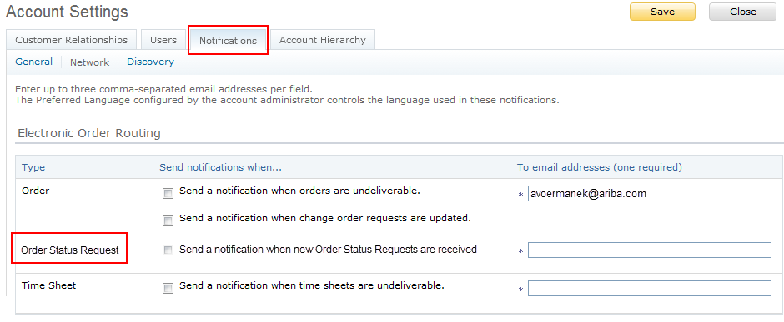
80.20 | The message send to the seller should just have a hyperlink to the UI element where the Order Status Requests are shown (Direct Action) | Must | AN
80.30 | Ariba Network/Network Settings/Electronic Order Routing/Notifications (at the very bottom):  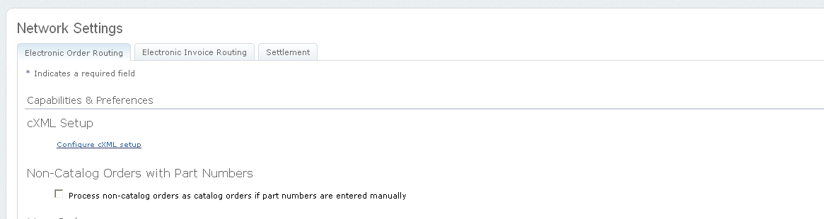  …..
80.40 | The message send to the seller should just have a hyperlink to the UI element where the Order Status Requests are shown (Direct Action) | Must | AN

Feature Requirements
Copy of Business Requirements
<For check-off if the features below are addressing all Business Requirements>

< Feature name XXX (Must, Should, Nice to have)>
<Details>

< Detailed Feature >
<Optional Further details>

< Feature name XXX (Must, Should, Nice to have)>
<Details>

Reports External / Internal

< New report XXX or impacted existing report XXX >

< Report-specific characteristics >
<Prepackaged or enable ad hoc reporting? Details; if prepackaged, include proposed solution folder location>

< Report “Mock-up” >

User Impact and Change Management
\\maytag\ucdg\12s3\UI Wireframes and Screens\12S3-607 Order Status Request

Part 1: Impact Assessment
Using the following attributes as a guide, explain the user impact.
- Type of change. Indicate whether you expect the business requirements described in this document to:
- Extend/add-to an existing feature (e.g. new steps / screens / fields in a workflow)
- Reduce/deprecate an existing feature (e.g. removes steps / screens / fields from a workflow)
- Add a net new capability (brand new area)

- Level of Complexity for end user. Indicate whether you expect the relative complexity of the solution to be:
- Low (takes less than 5 minutes to explain without any visual aids)
- Medium (takes between 5-15 minutes to explain with help of some visual aids)
- High (takes more than 15 minutes to explain and requires extensive visual aids)

- Target user. Who is the expected target audience for your use cases?
- Business Administrators only (typically < 5% of all users)
- Expert Users and Business Administrators (typically < 20% of all users)
- End Users
- Suppliers
- Other (please specify)

- Is an On/Off switch required for this feature? If a switch is needed, what requirements do you have for enablement?
- Self Service by User
- Self Service by Customer Admin
- Service by Support (Should only rarely be used as a business requirement)
- None (it’s On by default for all users)
<Details>

Part 2: Special Communication, Training Requirements
For every feature, the baseline deliverables for communication and training are the Feature Guide and the Early Access webinar respectively.
If this feature is likely to require additional support for rolling out, identify that here. For example, if it represents a change to an already existing feature and doesn’t have an On/Off switch, is there a need alert customers – why, why not? Through what means - special email, account management, other? What type of training aids will be necessary - video guides, live training session to handle Q/A, Instructor-Led-Training, etc.>
<Details>

Change management communication tools

Knowledge Transfer
(owner: solution management, review with Doc and Marketing)
- Ariba driven Customer sessions (supplier and buyer)
- Buyer driven reach out to suppliers

Email communication
(owner: readiness team)
- Ariba Change communicated as part of release announcements to all AN/AD buyers

UI embedded
(owner: solution management)
- “New Release Popup” -> content (owner: Doc team): distilled from Release Guide

Help
(owner: Doc team)
- Release guides
- Site help on the top of the page (with expand button)
- UI tool tips (only if really needed, the label itself should be intuitive)*
- Tutorials (on help)

Appendix

Sample Screenshots (e.g. existing Features)

